**Assignment**

1. **For each movie how many users rated it:**

**Answer:**

select m_dat.name ,

count(u_dat.movieid)

from m_data m_dat,

u_data u_dat

where m_dat.movieid = u_dat.movieid

group by m_dat.name;

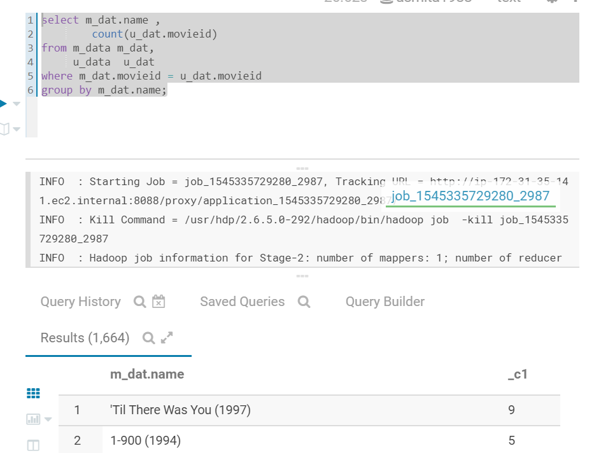

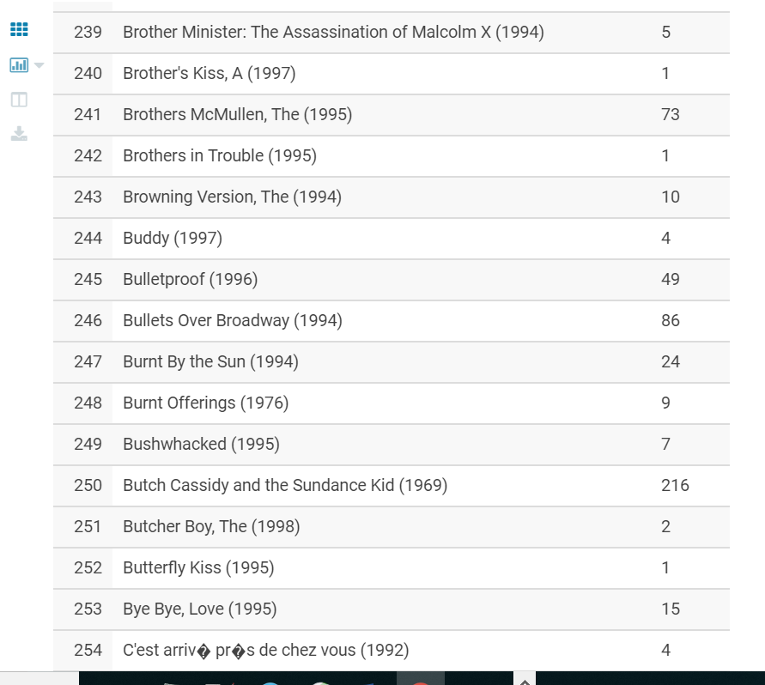

1. **For movies having more than 30 ratings, what is the average rating**

Answer:

select movieid,

count(movieid) count,

avg(rating) av

from u_data

group by movieid

HAVING count>30

order by av desc;

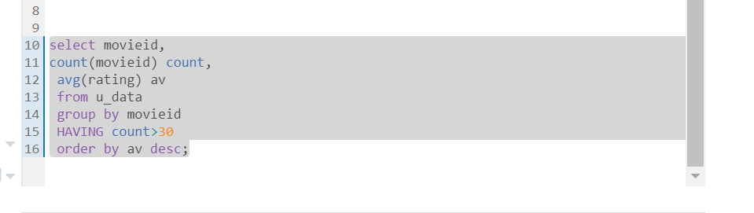

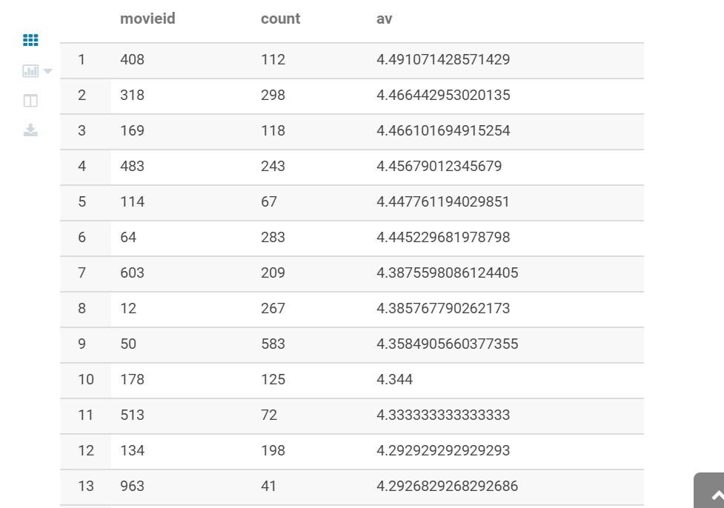

**Tableau project**

Select "Country", "Sentiment" from dimensions and "Number of records" from measures and click on "show me" to see the recommended chart by Tableau.

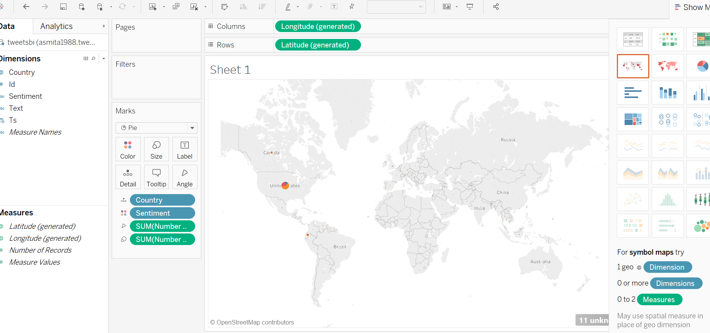

Now for United states :

Using mapcontrols :

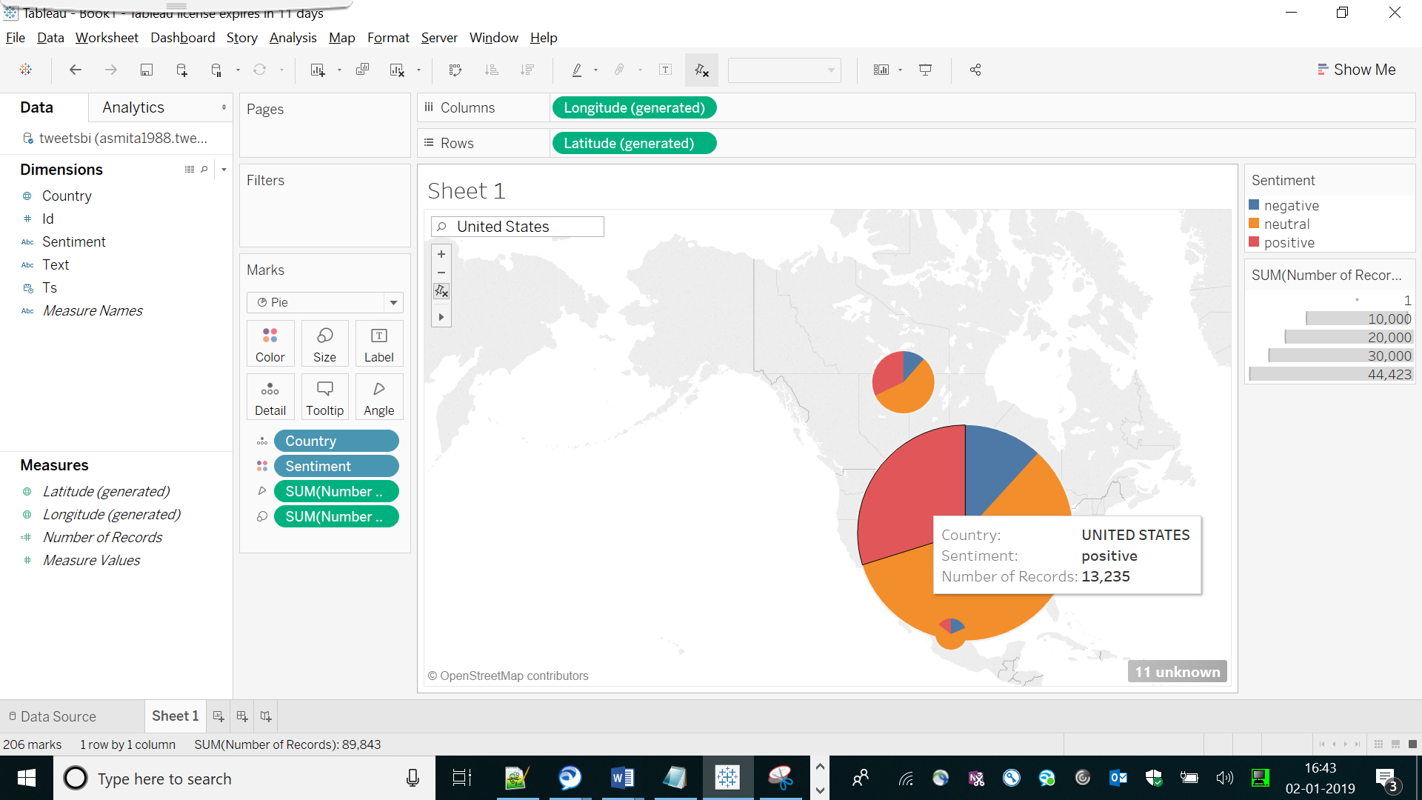

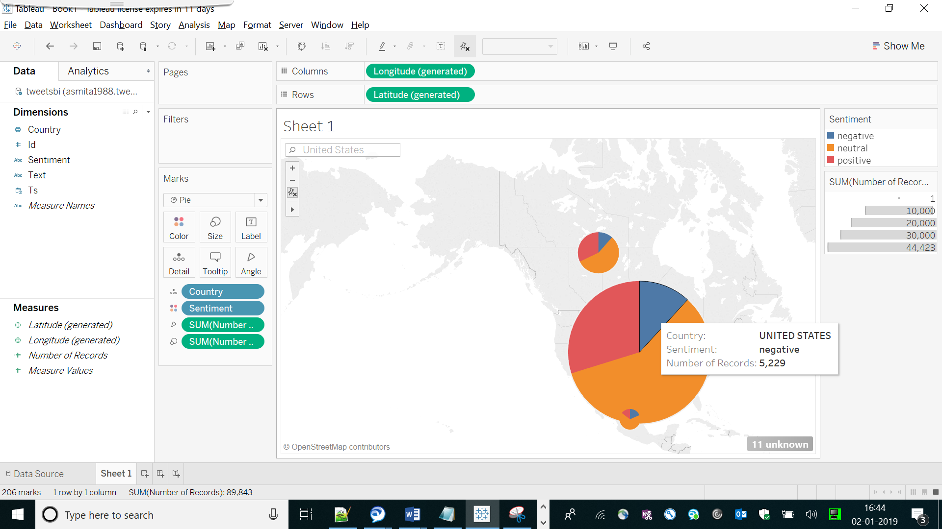

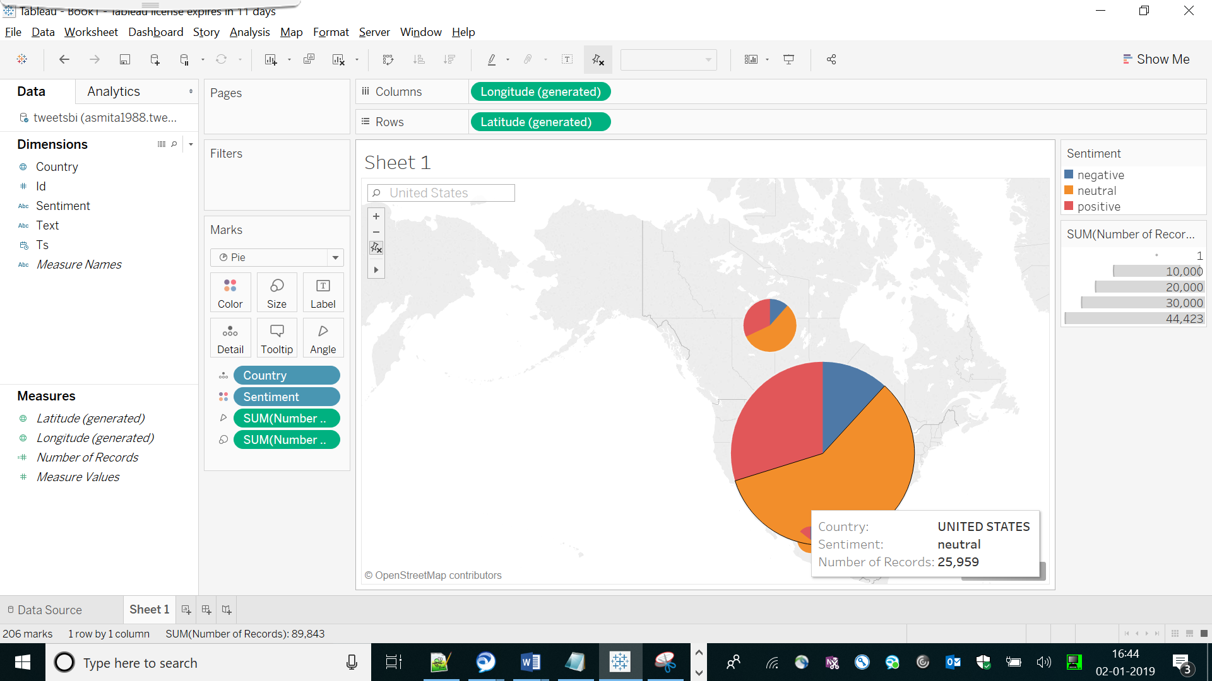

Hence for United states , majority of tweets are Neutral

Similarly for Mexico :

Now using search on MapControls ,

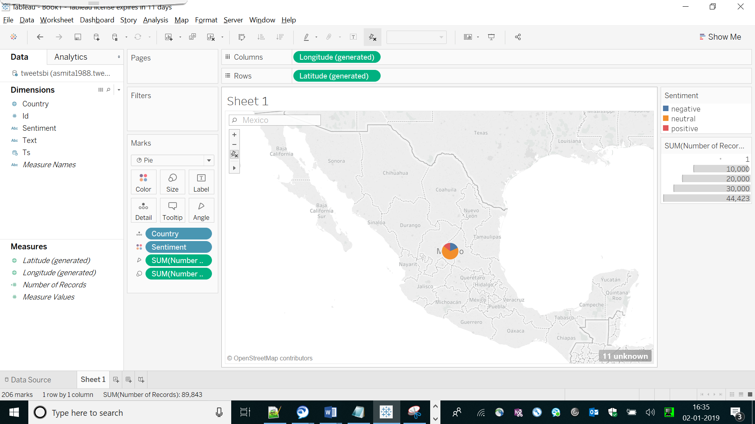

For neutral:

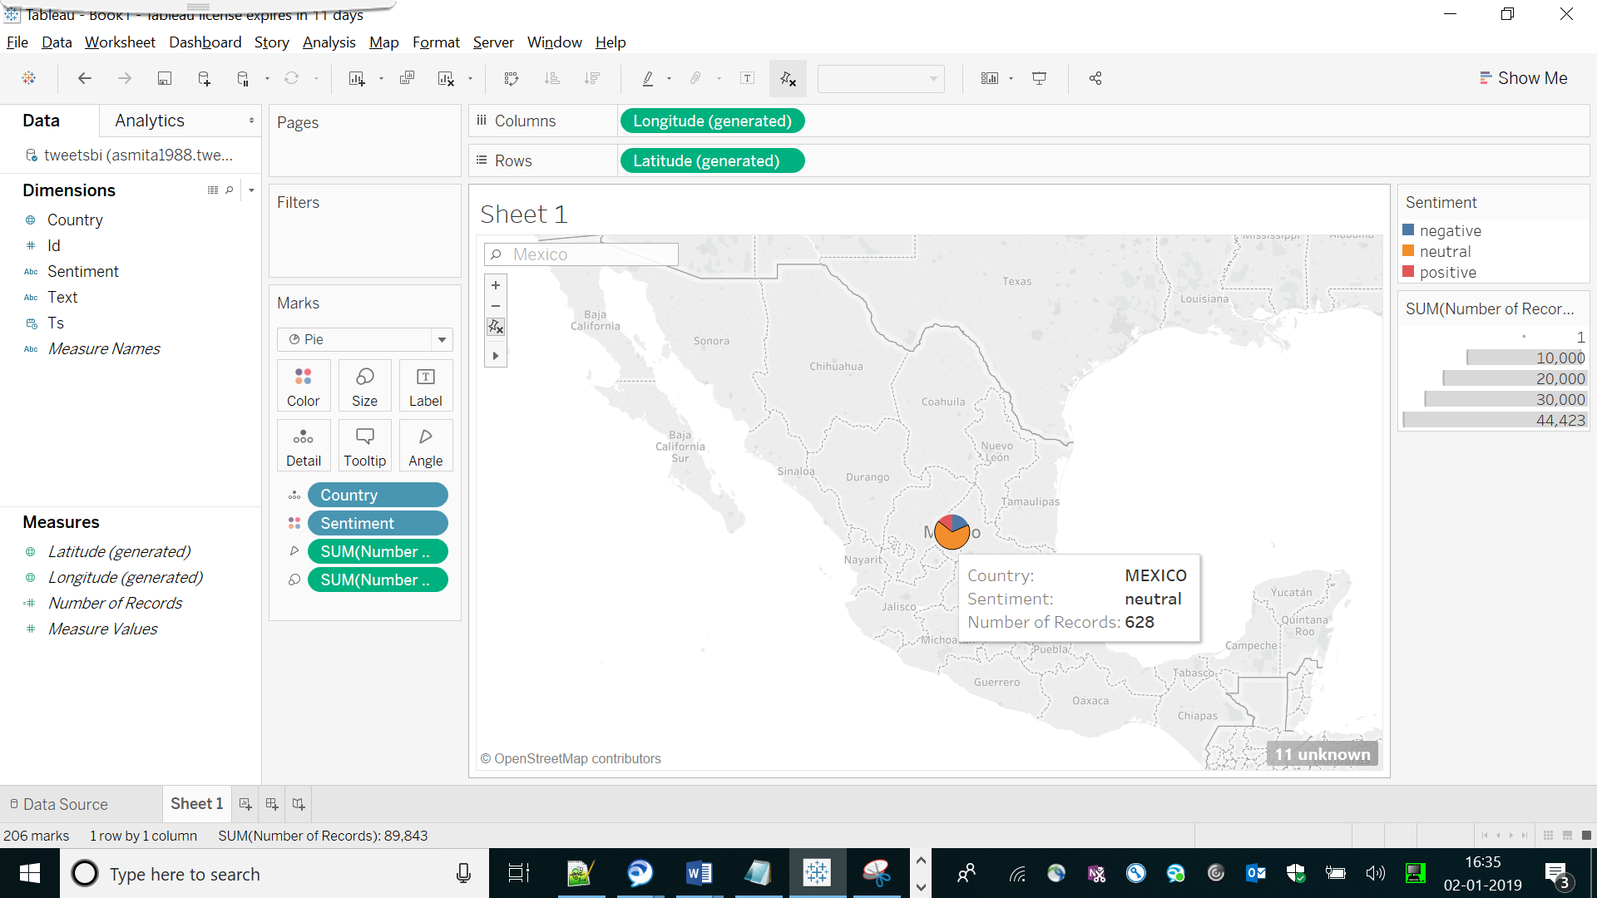

For positive

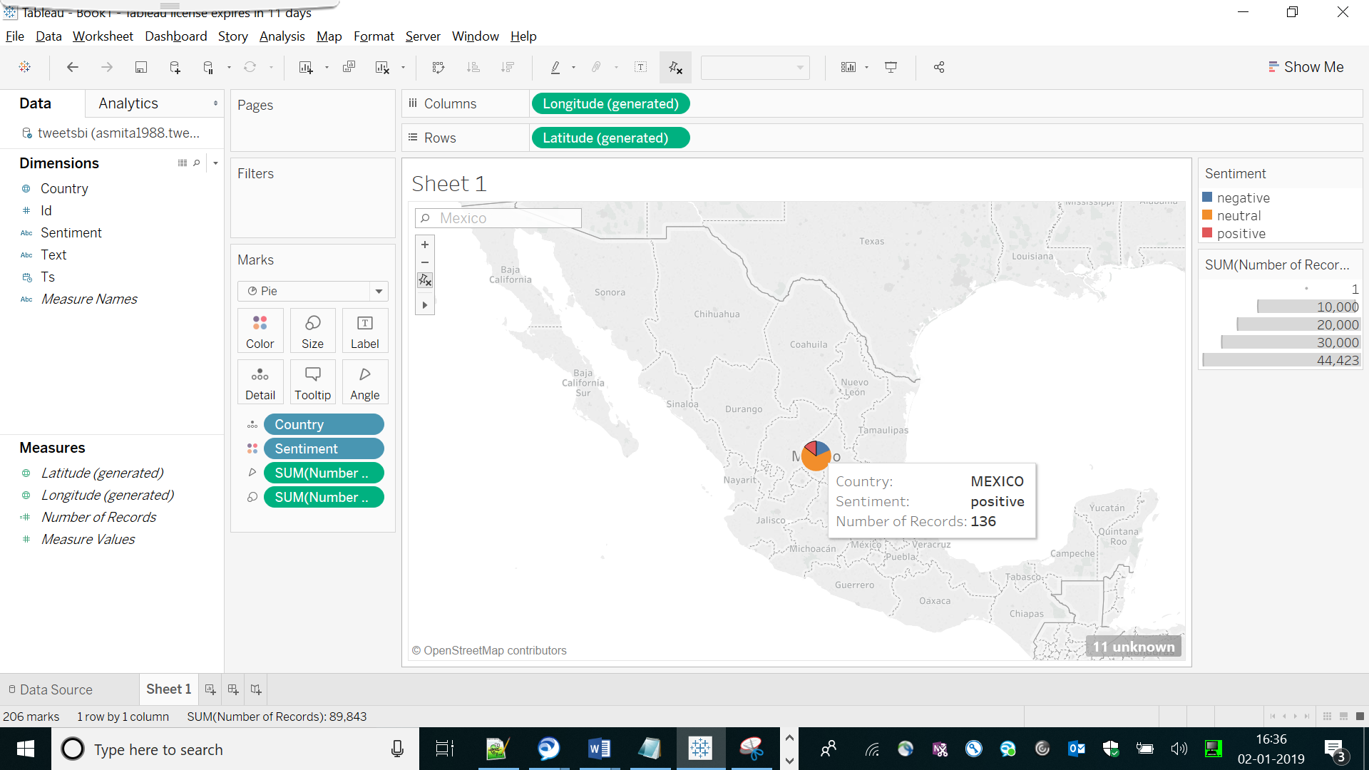

For negative

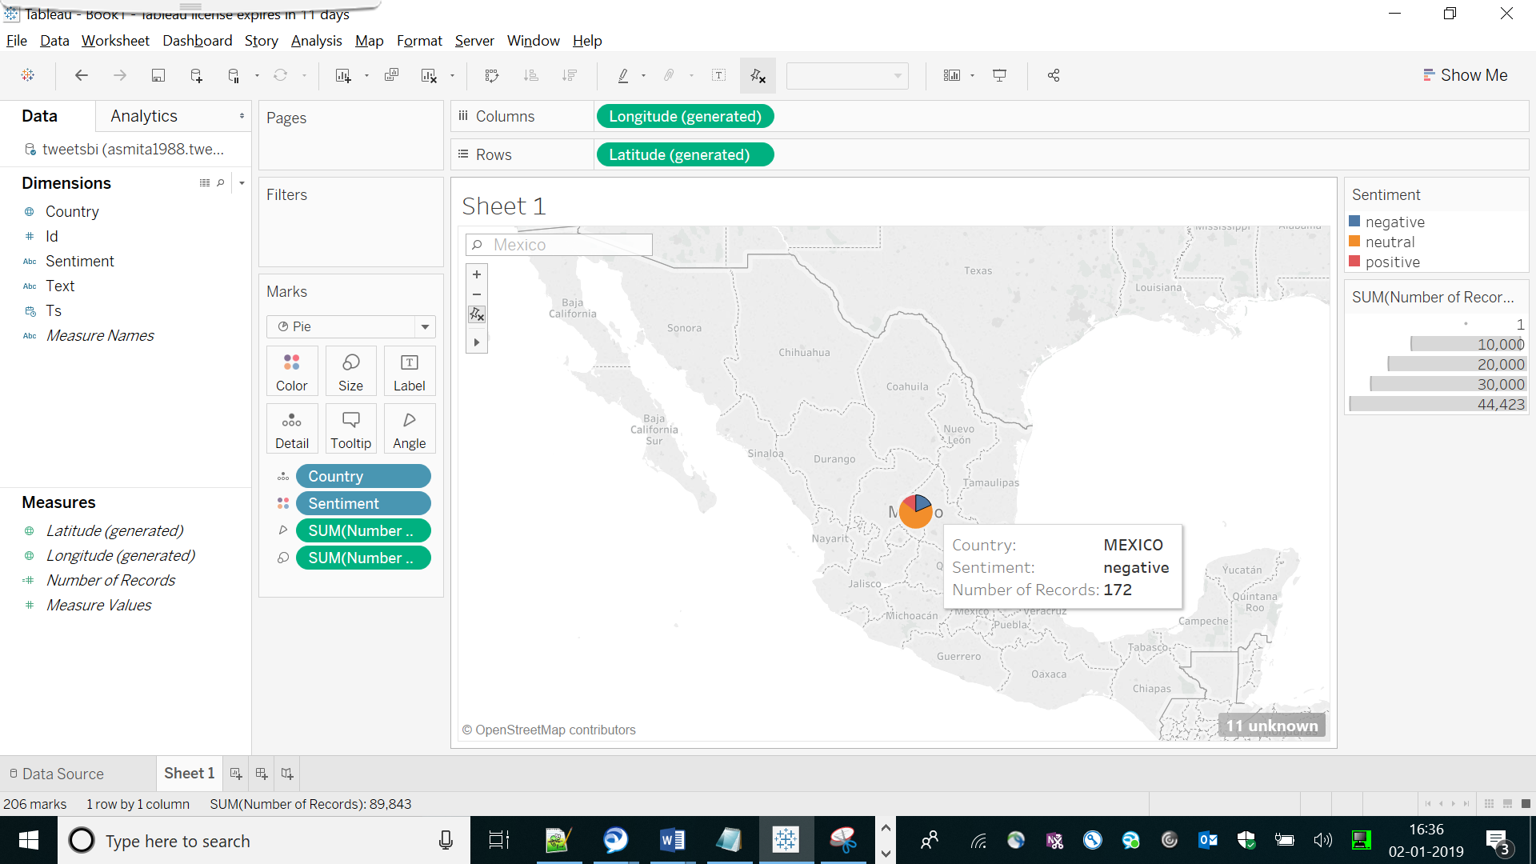

So for Mexico , negative is more than positive.

Now for China

Checking with map controls of China

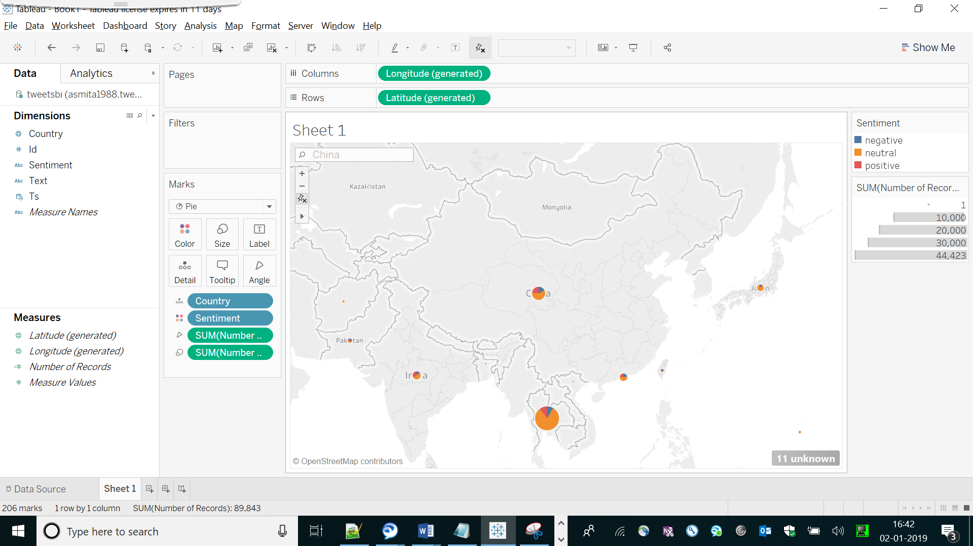

Negative:

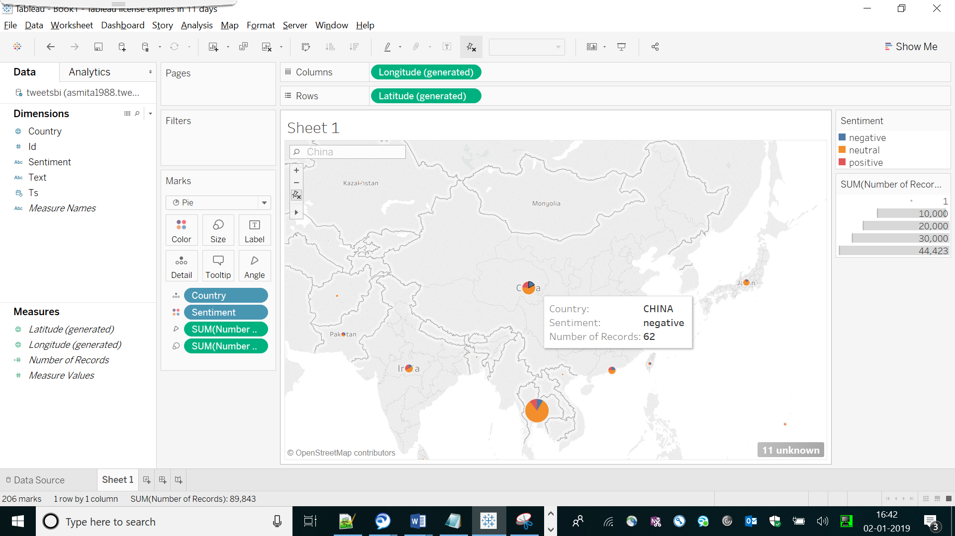

Neutral

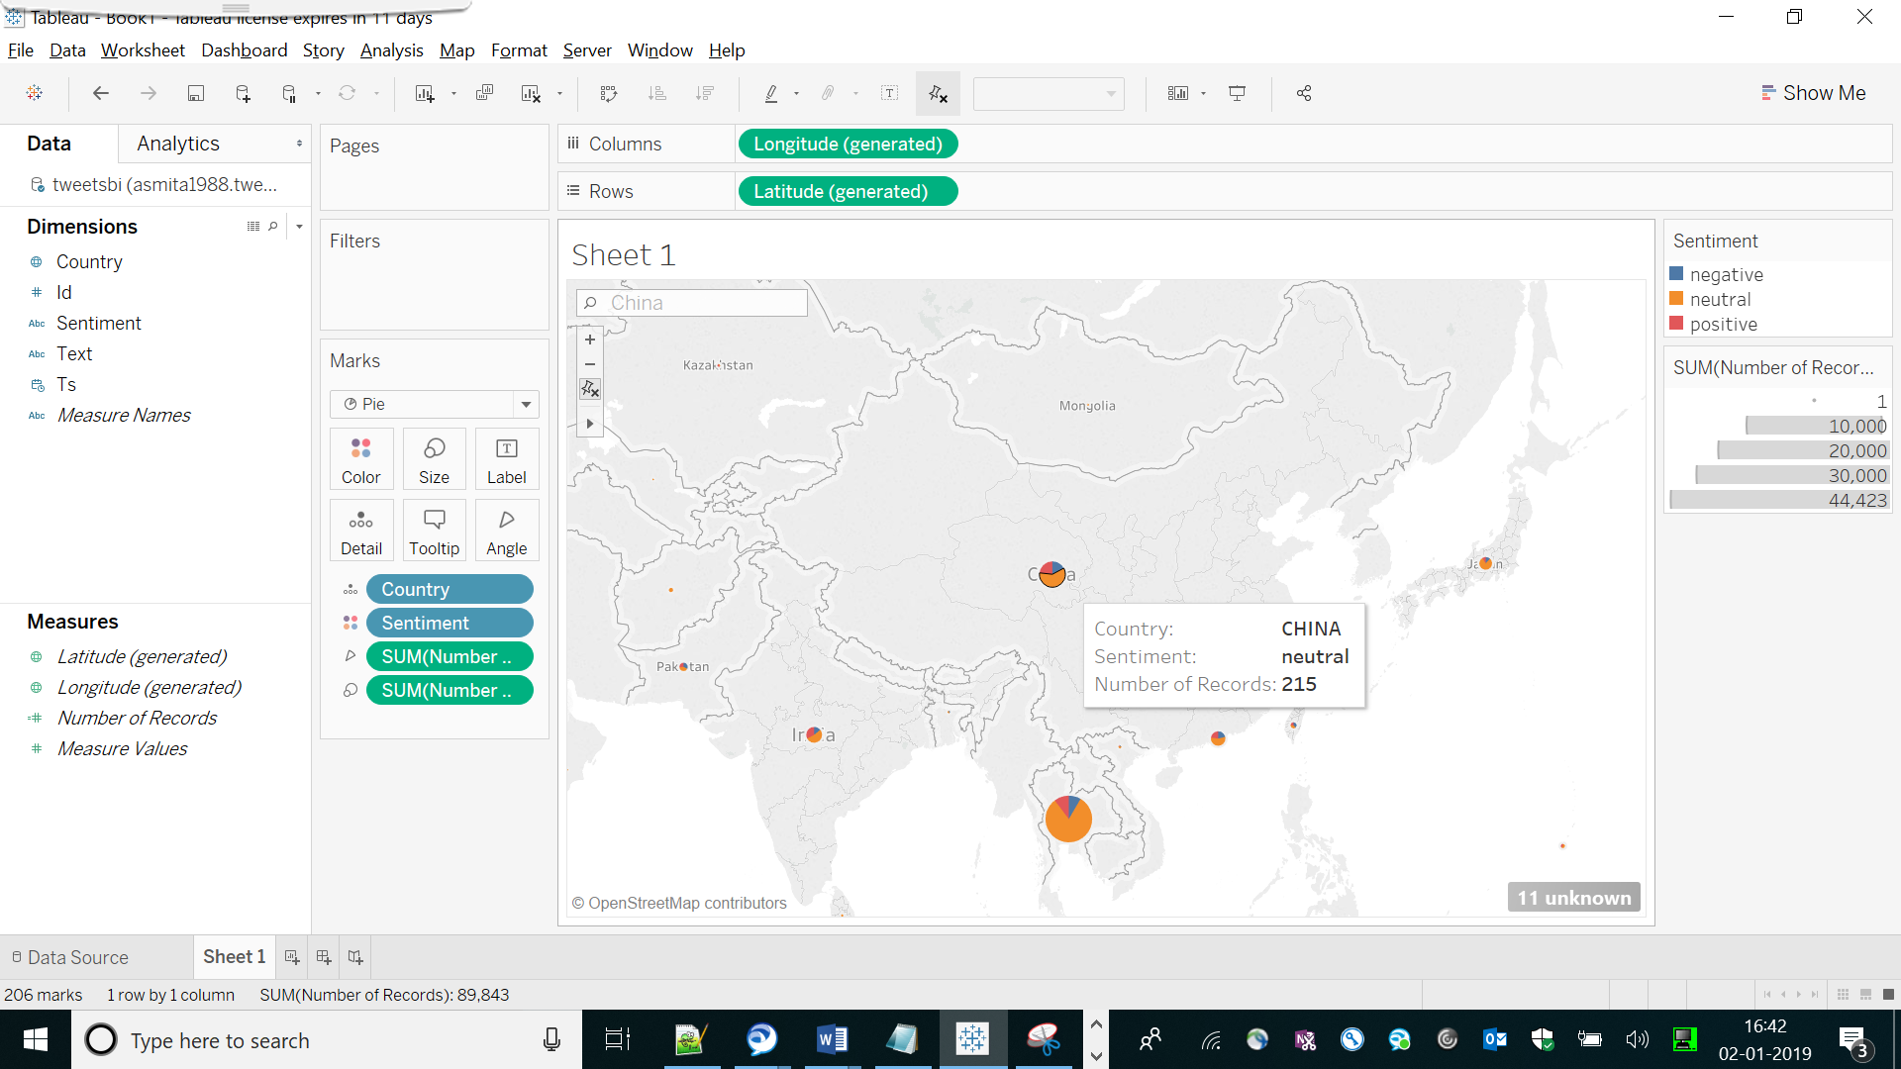

Positive :

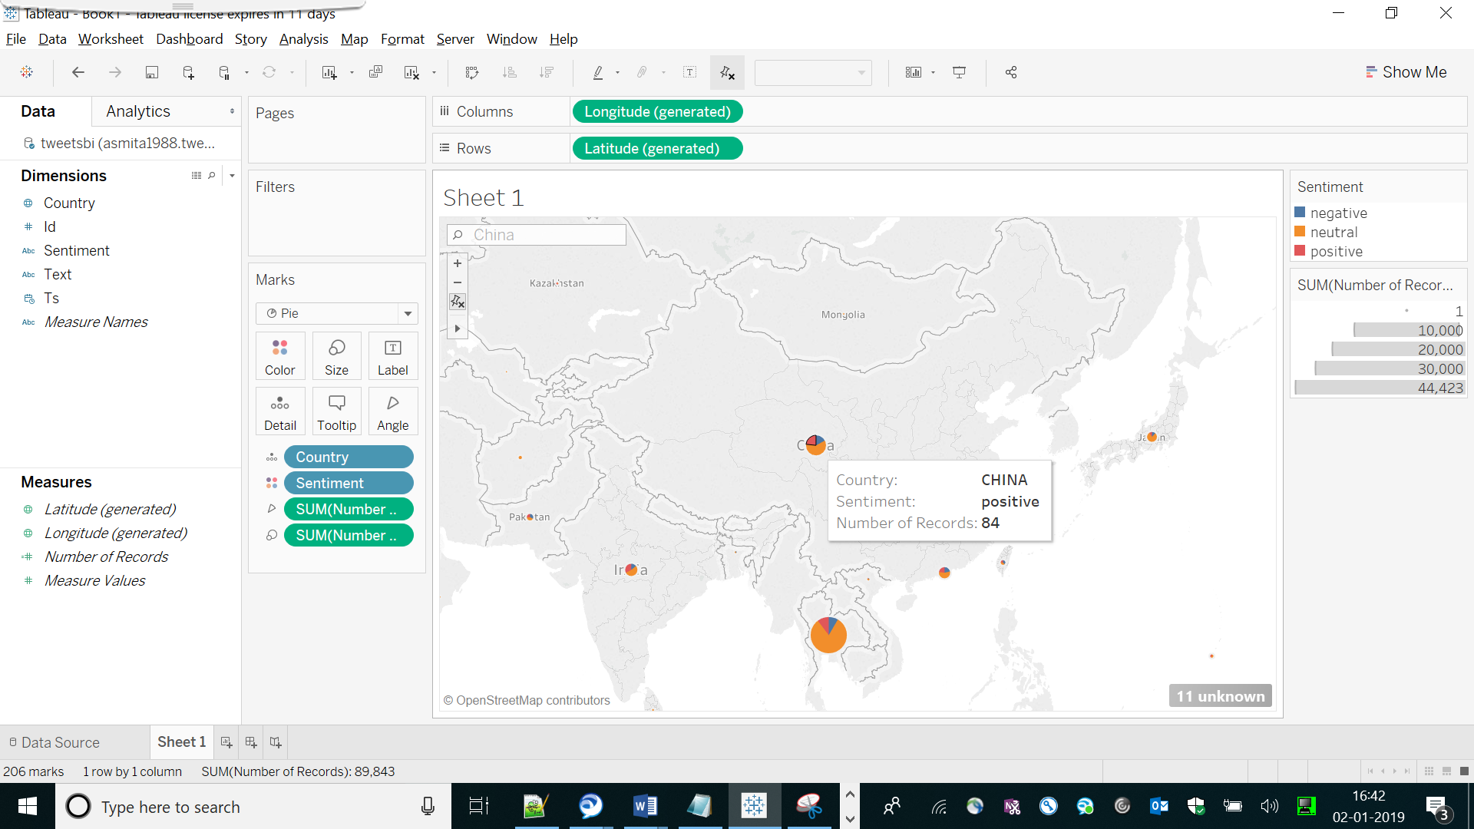

Hence majority of tweets for China : neutral